|  |  |  |  |  |  |
| --- | --- | --- | --- | --- | --- |
| Date | 1-Dec-22 | | | Tester Name | Janette Paus |
| Environment | Penfax - Test 2 | | | Login used |  |
| Operating System | Windows | Version: 21H2 | Update Number: | | |
| Software Used | Select Software | Version: 170.0.1418.56 | Update Number: | | |
| Select Software | Version: | Update Number: | | |
| Application Release version | R22.4.1 | | | | |
| Test Case Title | E20.03b | | | | |
| Test Type | Regression | | | | |
| Test Scenario | Reverse Member Deposit with Service (after Valuation) | | | | |
| Expected Results | Once the deposit is reversed, there will be no financial impact to the member and the amount of service will not show any under “transferred in service” | | | | |
| Pass/Fail | Select | | | JIRA# | <enter the new JIRA ticket number if the test case failed> |

Process Deposit With Service:

Add remittance for deposit:

Accounting, Remittance Management, Add remittance

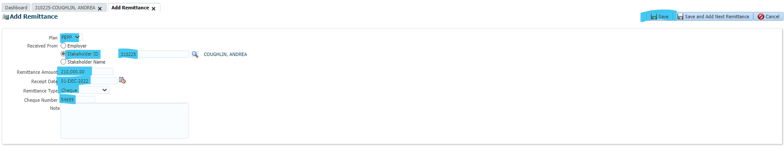

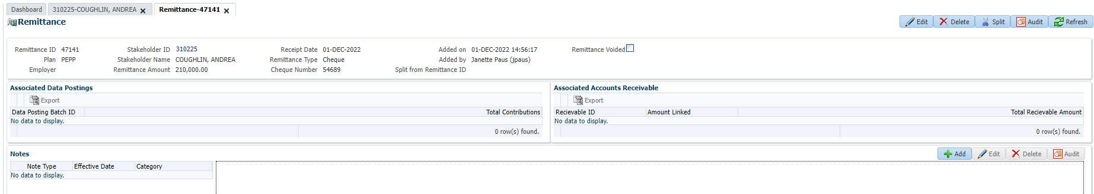

Search the member, open payroll history, and click Add

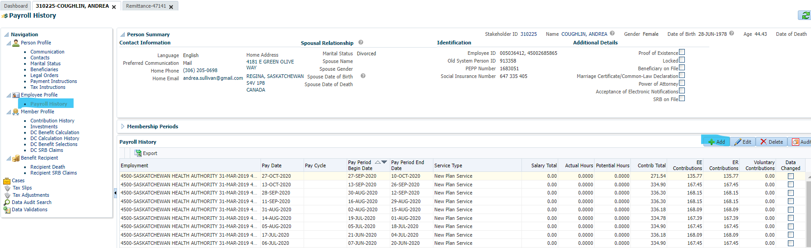

Add the service (that’s in the last year eg. January 2021 to March 2021, make sure the calendar year’s don’t overlap).

Add the receipt date, receipt number (based on the remittance)

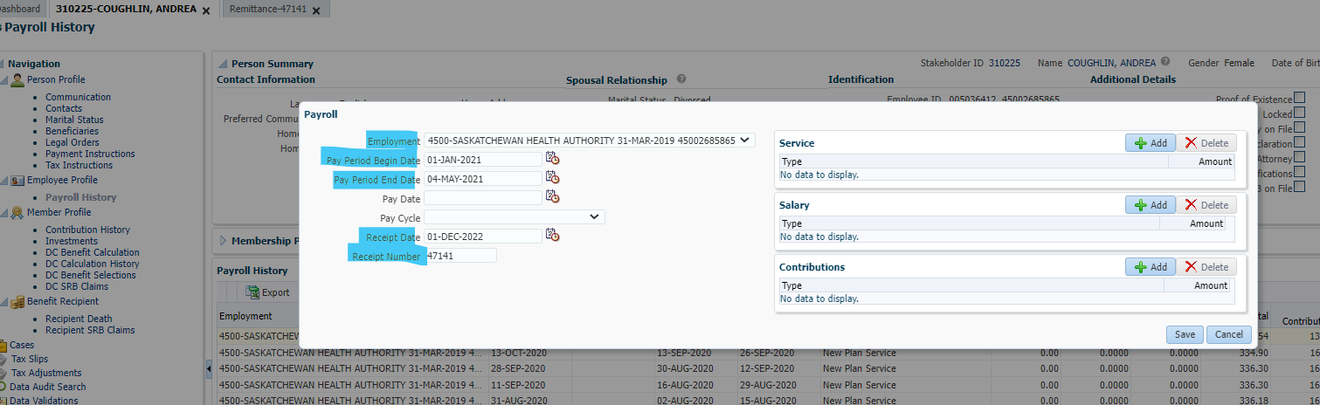

Add the total amount of purchased service (up to 2 decimal places), 20.46 years

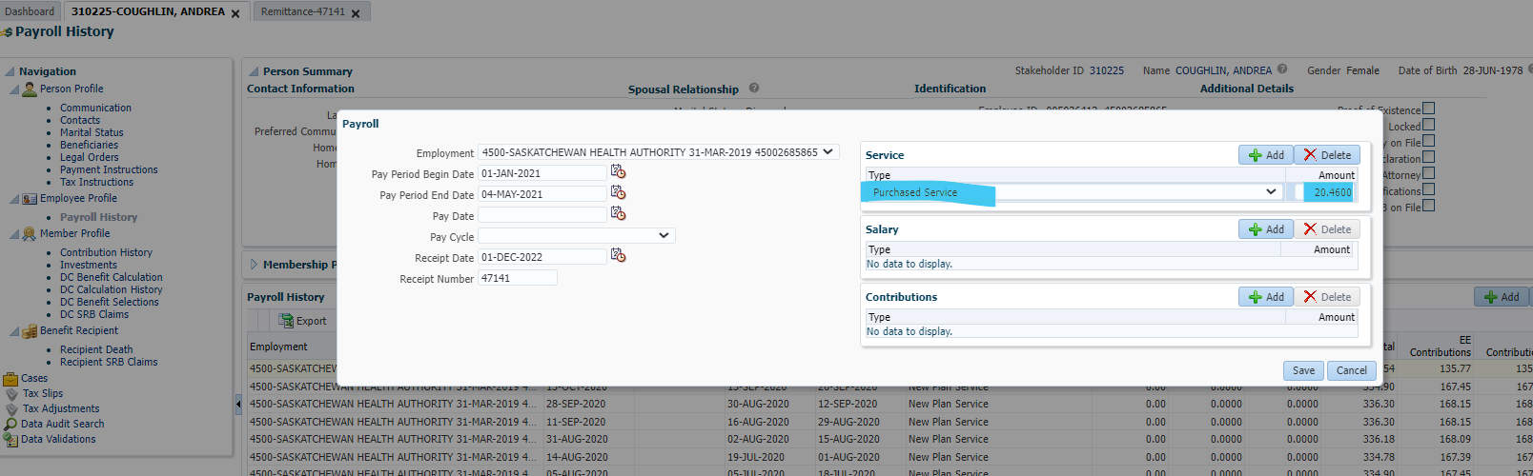

Add in contribution amount and $$

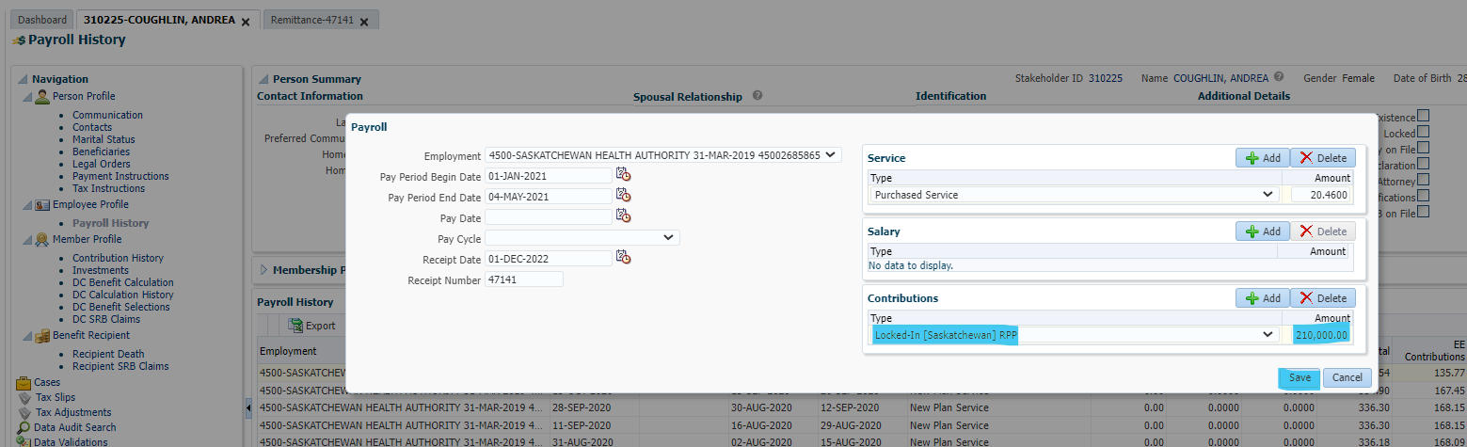

Click Save, ignore warning and click Accept and Continue:

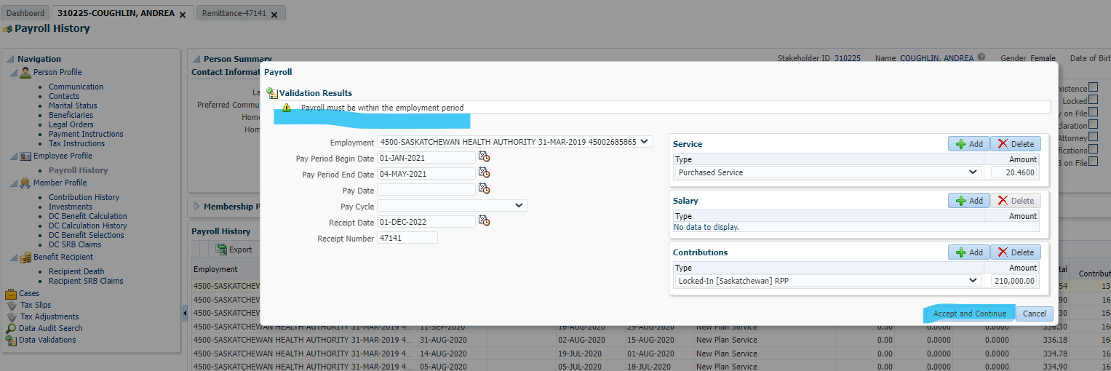

Add another record with the rest of the service dates included to make up the 20 years and Type of Purchased Service with $0.00. No remittance added to the 2nd transaction & click save

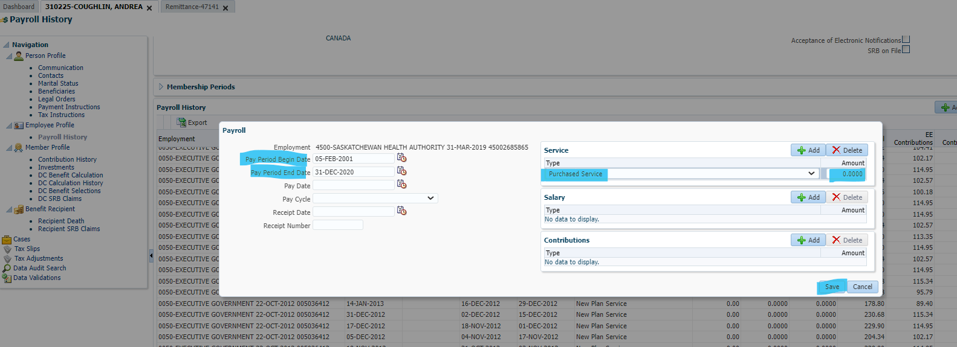

Both will now show under payroll history (you may have to scroll:

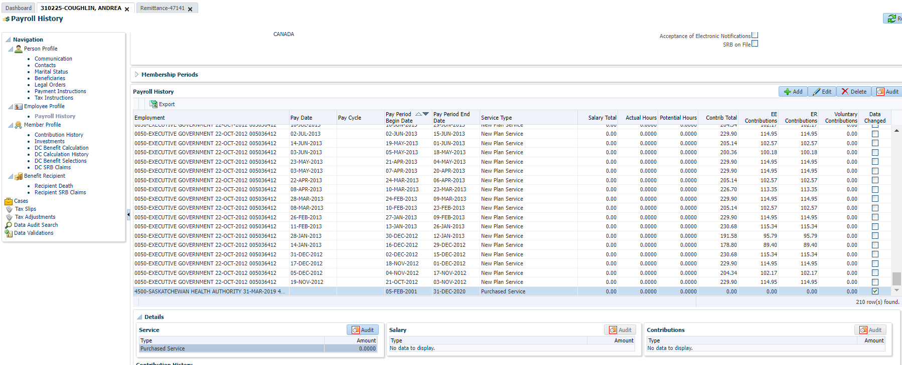

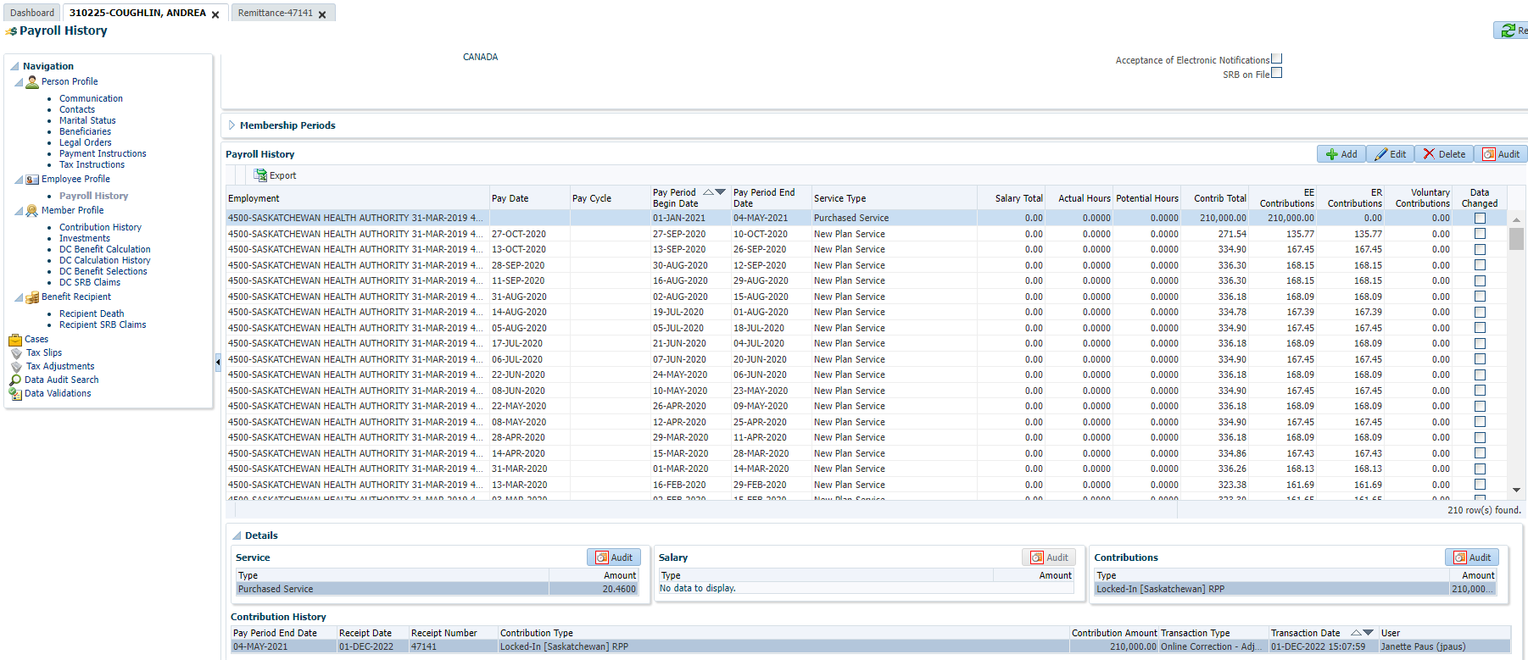

To avoid breakage, go to contribution history and change the effective date on the transaction to the current date.

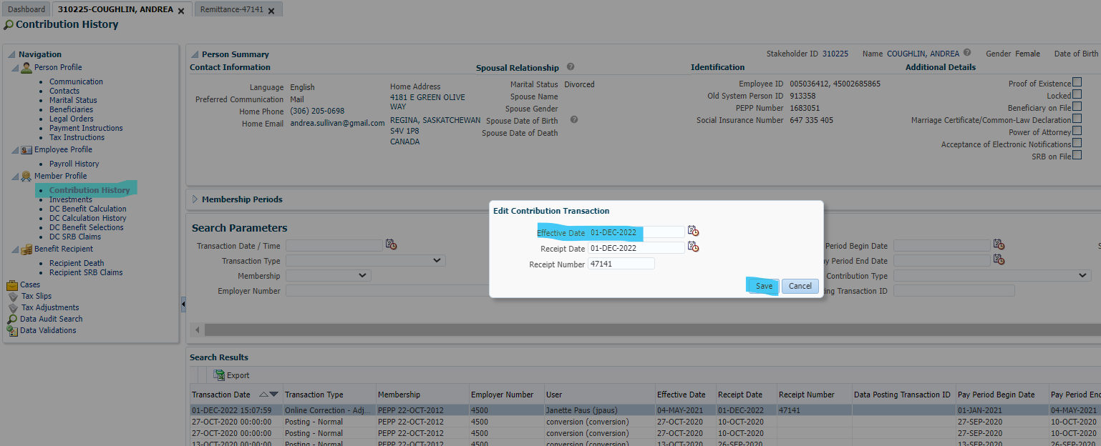

Service should be added overnight

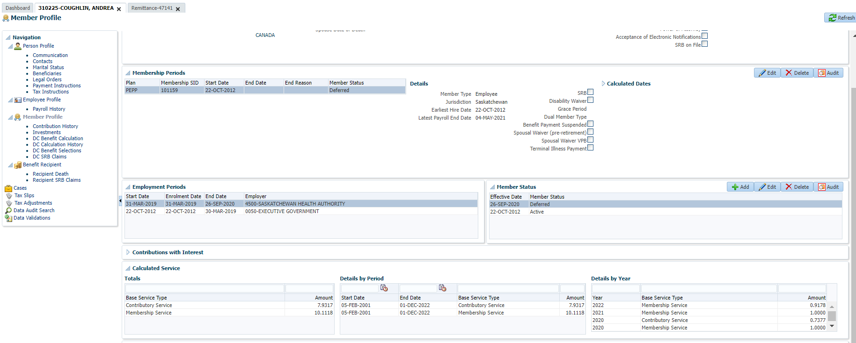

Check tomorrow re: service & process reversal.

Highlight record and press reverse.

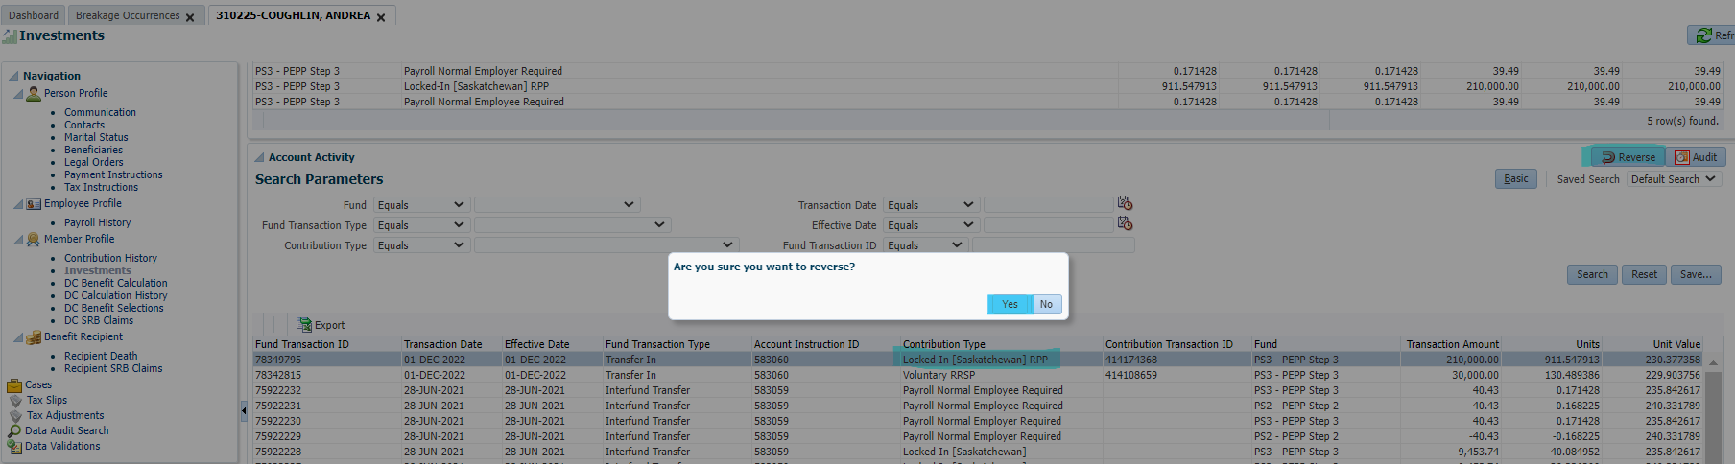

For BOTH records that were added yesterday, go to payroll history, highlight and delete.

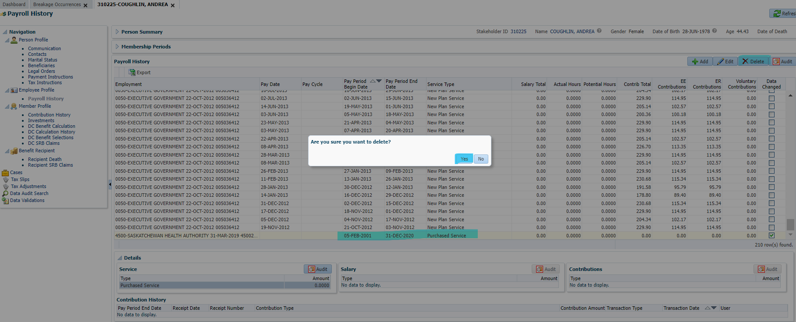

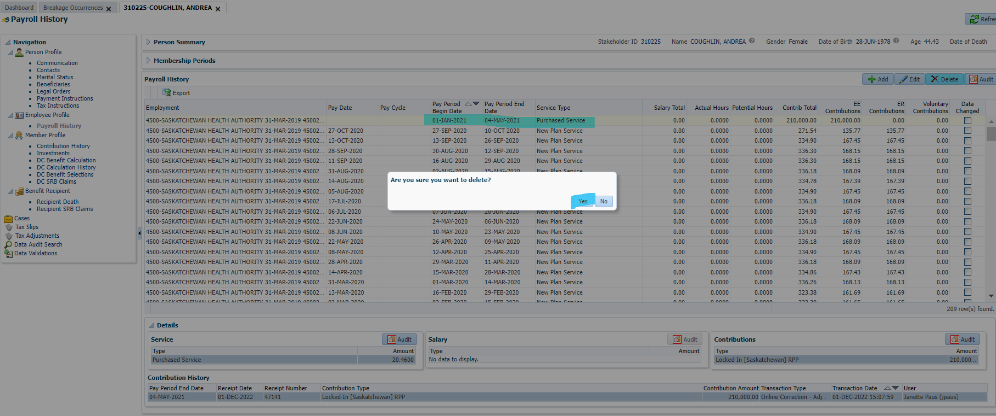

Next Day

Investment account activity shows money going in and out.

Contribution history shows a positive and negative transaction.

Units removed from Account.

Breakage is showing in correct type, amount is high as it’s calculating from May 2021 to Aug 2022 (see note above). This is correct how the system should work.

Funds were deposited again, completing reversal again:

Breakage is showing in correct type, amount is high as it’s calculating from May 2021 to Aug 2022 (see note above). This is correct how the system should work.

Funds were deposited again, completing reversal again:

The next day:

Go into contribution history, find the positive 210k entry, and hit delete. Delete is greyed out on every entry except the positive 210k entry.

*already completed this step in screen shot, forgot a screen shot prior to this step:

Day 3 (next day), confirm funds are still reversed & check service:

Confirmation: funds reversed correctly

No “transferred in service” showing after reversal, this is correct;